# **Problem 4 – Combinatorics**

This task is not a Combinatorics problem.

You like explosives. You have a lot of explosives. You are quite a crazy person.

You are given a system of pipes and **N** connecting parts. The pipes are bidirectional, so the water can flow both ways.

Your task is to find the connecting part, which if blown with an explosive, will leave exactly **M** separated parts of the system.

For example:

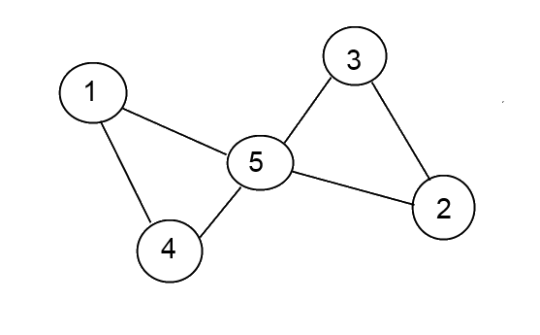

Let **M** equals **2**. We need to put an explosive on **5**, because after the explosion, there will be two separated parts of the system – **1-4** and **2-3**.

#### Input

* The input data should be read from the console.
* On the first line there will be **N** – the total number of connecting parts in the system.
* On the second line there will be **M –** the separated parts of the system after the explosion.
* On the next **N** lines there will be the connections between the connecting parts. On the first of the lines there will be connections for the first connecting part. On the second – the connections of the second connecting part and so on.
* The input data will always be valid and in the format described. There is no need to check it explicitly.

#### Output

* If the system is not connected initially – print the number **-2**.
* If the system is connected initially but with one explosive it will remain connected, print the number **-1**.
* If the system is connected initially but we cannot separate it to exactly **M** parts with one explosive – print the number **0**.
* If the system is connected initially and we can separate it to exactly **M** parts – print the part we want to explode.

#### Constraints

* **N** will be between **2** and **1000**, inclusive.
* **M** will be between **2** and **10**, inclusive.
* There will be only one possible solution in all tests.
* Allowed working time for your program: **0.3 seconds**. Allowed memory: **16 MB**.

#### Examples

|  |  |  |
| --- | --- | --- |
| **Input** | **Output** | **Comment** |
| 5  2  4 5  3 5  2 5  1 5  1 2 3 4 | 5 | If we put an explosive on 5, the system will be separated in exactly two parts. We print 5. |